The Red House
135 Station Road
Impington, Cambridge
CB24 9NP, UK

t. +44 (0) 1223 233971
e. secretariat@iwc.int
w w w.iwc.int

Report on infractions of the International Convention for the Regulation of Whaling, 1946 and summary information on catches
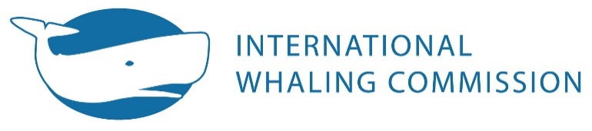
Please complete this form as fully as possible, preferably electronically, and return by
Monday 20 May 2019 to secretariat@iwc.int
Aboriginal subsistence / commercial whaling : Please complete Tables 1 to 5 as appropriate
Other Infractions : If the infractions being reported are not associated with aboriginal subsistence or commercial whaling, please complete Tables 4 and 5 as appropriate

Contracting Government

Table 1.
Whaling activity (e.g. aboriginal subsistence / commercial)
Season | 2018
Number of Active crews/vessels

Table 2. Summary of information on inspection and observation:
Percentage of catch under direct national inspection
Percentage of catch under inspection under an international programme

Table 3. Summary of information on catches for 2018 and, if any, infractions:
Species | Total animals landed |  |  | Additional animals struck but lost | Catch/strike overrun  (give number) | Other infractions (give number)
 | Male | Female | Total

Table 4. Details of any infractions committed in 2018 (2018/19 Antarctic season). Please list whales by species. The action/penalty should be shown individually for each whale.

No. | Species | Sex | Length | Date | Infraction (specify)¹ | Explanation² | Penalty/Action³ | Investigation complete?⁴
1.
2.
3.
4.
5.
6.
7.
8.
¹ e.g. prohibited species; quota over-run; lactating whale and calf; killing method; outside legal size limits.
² Please include location in addition to date and source of initial information.
³ Please include both monetary and non-monetary penalties.
⁴ If investigation is not complete, please indicate anticipated completion date.
Table 5. Details of any unresolved infractions committed in previous years and follow-up actions. The year and No. should match the year in which the infraction was first reported.

Year  & No. | Species | Sex | Length | Date | Infraction (specify)¹ | Explanation² | Penalty/Action³ | Investigation complete?⁴
¹ e.g. prohibited species; quota over-run; lactating whale and calf; killing method; outside legal size limits.
² Please include location in addition to date and source of initial information.
³ Please include both monetary and non-monetary penalties.
⁴ If investigation is not complete, please indicate anticipated completion date.

Use of this form is not compulsory. However, Contracting Governments do have to fulfil their reporting obligations under Article IX.4 of the Convention.

