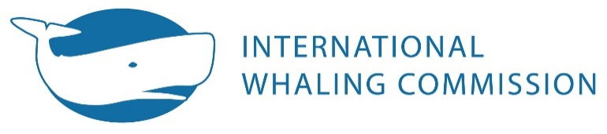
The Red House
135 Station Road
Impington, Cambridge
CB24 9NP, UK

t. +44 (0) 1223 233971
e. secretariat@iwc.int
w w w.iwc.int

Checklist of Information Required or Requested under Section VI of the Schedule

Please complete this form as fully as possible, and send preferably electronically to secretariat@iwc.int . Not all of the items are relevant to aboriginal subsistence whaling.

Contracting Government
Season

Item [and relevant Schedule Paragraph] | Collected, recorded or completed |  | Place(s) information sent or held (tick all that apply). 1 = sent to IWC Secretariat;  2 = paper to Sci. Committee;  3 = national archives;  4 = other (specify) |  |  |  | % of catch or fleet for which collected, recorded or completed
 | Yes | No | 1 | 2 | 3 | 4
Date each whale taken [27]
Time each whale taken [24]
Position each whale taken [27]
Species each whale taken [24, 27]
Length of each whale taken [24]
Sex each whale taken [24, 27]
If female, whether lactating [24]
[Give % of females inspected]
Length and sex of foetus, if present [24, 27]
Collection of either both ovaries or combined weight of both testes [27]
- Analysis of this material [29]
Collection of at least one earplug/tooth [29]
- Analysis of this material [29]
Method used to kill each whale, other than harpoon [25]
Number of whales struck and lost [25, 27]
Full explanation of each infraction [24]
Amount of oil of each grade, meal fertiliser and other products [27]
Name and GRT of each factory ship [28]
Notification of factory ship to operate south of 40°S [26]
Number of baleen whales taken south of 40°S at end of each week (or day, if applicable) [26]
List of land stations in operation [28]
GRT, length, HP of each catcher [28]
No days each catcher on whaling grounds [28]
Starting and closing date for each catcher for the season [28]
Markings identifying catcher and order of catching [28]
Time spent each day on different components of the whaling operations [28]
Logbook information given in Appendix A [28]
Other suitable indicator of effort for small-type whaling [28]
No. miles searched by aircraft each day [28]
Provision of national laws and regulations relating to whales and whaling and any changes [31]

